**SPRAWOZDANIE**

Zajęcia: Grafika komputerowa

Prowadzący: prof. dr hab. Vasyl Martsenyuk

# **Laboratorium**

Data: 18.03.2024

**Temat:**

"Język opisu sceny SVG"

# **Wariant:**

# **Zadanie nr. 1:** jedenastokąt zamiast kół

Mateusz Żelazo

Informatyka I stopnia

stacjonarne, 4 semestr

Gr.3a

### 

1. **Polecenie:**

Opracować scenę hierarchiczną zgodnie z obrazem używając zamiast kół wielokąty obracające się (animacja!) według wariantu. Opracowanie powinno być w języku SVG.

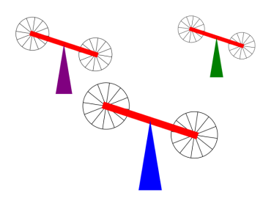

1. **Wprowadzane dane:**

**<svg version="1.1" xmlns="http://www.w3.org/2000/svg" xmlns:xlink="http://www.w3.org/1999/xlink" width="800"**

**height="600" viewBox="0 0 800 600" preserveAspectRatio="xMidYMid">**

**<g transform="translate(250, 300)">**

**<g transform="translate(25, -20)">**

**<polygon style="fill: orange"**

**points="92.06267664155905, 77.03204087277987, 70.77075065009433, 95.48159976772592, 42.88425808633574, 99.49107209404664, 17.25696330273575, 87.78747871771293, 2.0253513192751385, 64.08662784207151, 2.0253513192751313, 35.91337215792851, 17.25696330273574, 12.212521282287092, 42.88425808633574, 0.5089279059533638, 70.7707506500943, 4.518400232274075, 92.06267664155904, 22.967959127220087, 100, 49.999999999999986">**

**<animateTransform attributeName="transform" attributeType="XML" type="rotate" from="0 50 50"**

**to="360 50 50" dur="10s" repeatCount="indefinite" />**

**</polygon>**

**</g>**

**<g transform="translate(310, 30)">**

**<polygon style="fill: orange"**

**points="92.06267664155905, 77.03204087277987, 70.77075065009433, 95.48159976772592, 42.88425808633574, 99.49107209404664, 17.25696330273575, 87.78747871771293, 2.0253513192751385, 64.08662784207151, 2.0253513192751313, 35.91337215792851, 17.25696330273574, 12.212521282287092, 42.88425808633574, 0.5089279059533638, 70.7707506500943, 4.518400232274075, 92.06267664155904, 22.967959127220087, 100, 49.999999999999986">**

**<animateTransform attributeName="transform" attributeType="XML" type="rotate" from="0 50 50"**

**to="360 50 50" dur="10s" repeatCount="indefinite" />**

**</polygon>**

**</g>**

**<rect width="300" height="20" style="fill:red" transform="rotate(10) translate(75, 5)" />**

**<polygon style="fill: blue;" points="200, 200, 250, 200, 225, 50">**

**</polygon>**

**</g>**

**<g transform="translate(50, 100) scale(0.7 0.7)">**

**<g transform="translate(25, -20)">**

**<polygon style="fill: orange"**

**points="92.06267664155905, 77.03204087277987, 70.77075065009433, 95.48159976772592, 42.88425808633574, 99.49107209404664, 17.25696330273575, 87.78747871771293, 2.0253513192751385, 64.08662784207151, 2.0253513192751313, 35.91337215792851, 17.25696330273574, 12.212521282287092, 42.88425808633574, 0.5089279059533638, 70.7707506500943, 4.518400232274075, 92.06267664155904, 22.967959127220087, 100, 49.999999999999986">**

**<animateTransform attributeName="transform" attributeType="XML" type="rotate" from="0 50 50"**

**to="360 50 50" dur="10s" repeatCount="indefinite" />**

**</polygon>**

**</g>**

**<g transform="translate(310, 30)">**

**<polygon style="fill: orange"**

**points="92.06267664155905, 77.03204087277987, 70.77075065009433, 95.48159976772592, 42.88425808633574, 99.49107209404664, 17.25696330273575, 87.78747871771293, 2.0253513192751385, 64.08662784207151, 2.0253513192751313, 35.91337215792851, 17.25696330273574, 12.212521282287092, 42.88425808633574, 0.5089279059533638, 70.7707506500943, 4.518400232274075, 92.06267664155904, 22.967959127220087, 100, 49.999999999999986">**

**<animateTransform attributeName="transform" attributeType="XML" type="rotate" from="0 50 50"**

**to="360 50 50" dur="10s" repeatCount="indefinite" />**

**</polygon>**

**</g>**

**<rect width="300" height="20" style="fill:red" transform="rotate(10) translate(75, 5)" />**

**<polygon style="fill: purple;" points="200, 200, 250, 200, 225, 50">**

**</polygon>**

**</g>**

**<g transform="translate(450, 100) scale(0.5 0.5)">**

**<g transform="translate(25, -20)">**

**<polygon style="fill: orange"**

**points="92.06267664155905, 77.03204087277987, 70.77075065009433, 95.48159976772592, 42.88425808633574, 99.49107209404664, 17.25696330273575, 87.78747871771293, 2.0253513192751385, 64.08662784207151, 2.0253513192751313, 35.91337215792851, 17.25696330273574, 12.212521282287092, 42.88425808633574, 0.5089279059533638, 70.7707506500943, 4.518400232274075, 92.06267664155904, 22.967959127220087, 100, 49.999999999999986">**

**<animateTransform attributeName="transform" attributeType="XML" type="rotate" from="0 50 50"**

**to="360 50 50" dur="10s" repeatCount="indefinite" />**

**</polygon>**

**</g>**

**<g transform="translate(310, 30)">**

**<polygon style="fill: orange"**

**points="92.06267664155905, 77.03204087277987, 70.77075065009433, 95.48159976772592, 42.88425808633574, 99.49107209404664, 17.25696330273575, 87.78747871771293, 2.0253513192751385, 64.08662784207151, 2.0253513192751313, 35.91337215792851, 17.25696330273574, 12.212521282287092, 42.88425808633574, 0.5089279059533638, 70.7707506500943, 4.518400232274075, 92.06267664155904, 22.967959127220087, 100, 49.999999999999986">**

**<animateTransform attributeName="transform" attributeType="XML" type="rotate" from="0 50 50"**

**to="360 50 50" dur="10s" repeatCount="indefinite" />**

**</polygon>**

**</g>**

**<rect width="300" height="20" style="fill:red" transform="rotate(10) translate(75, 5)" />**

**<polygon style="fill: green;" points="200, 200, 250, 200, 225, 50">**

**</polygon>**

**</g>**

**</svg>**

1. **Link do zdalnego repozytorium:**

* https://github.com/Terminalk/GKLab

1. **Wynik działania:**

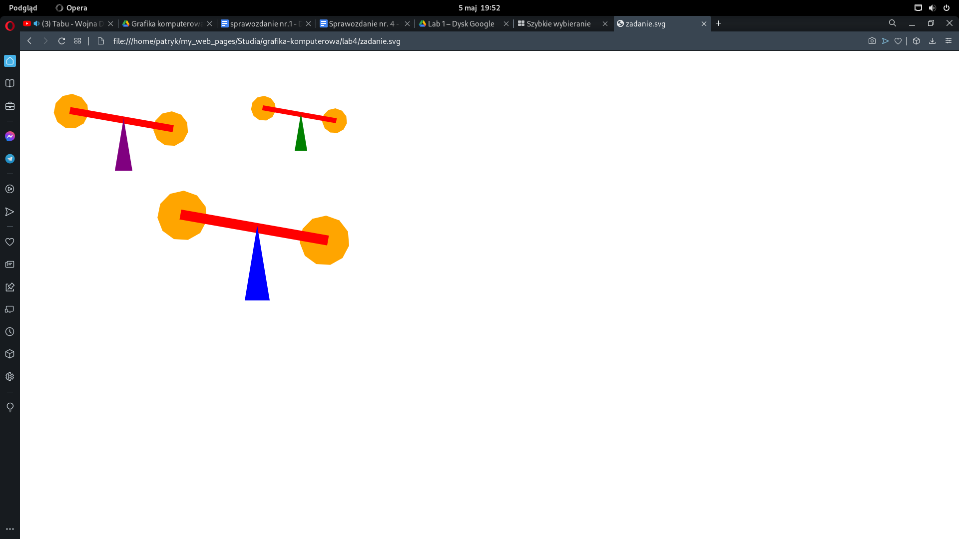

1. **Wnioski:**

Za pomocą języka SVG w łatwy sposób jesteśmy w stanie zrobić animację, przy pomocy rysowania wektorowego.

### 